Module 2 - Types of Cryptography
The aim of this module is to review the types of ciphers and all their particularities.

Slide 3 - Types of ciphers
depending on the type of operations: based on substitutions and based on transpositions
depending on the type of keys: symmetric methods (with secret key) and asymmetric methods (with public key)
depending on the method by which the data is processed: block ciphers and stream ciphers

Slide 4 - Classification of ciphers (figure)
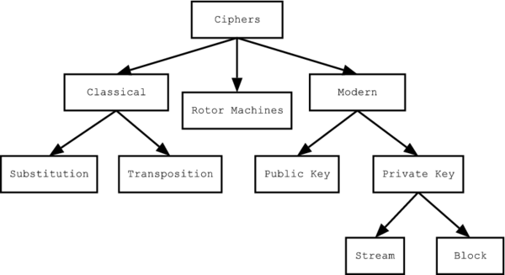
There are a variety of different types of encryption. Algorithms used earlier in the history of cryptography are substantially different from modern methods.
Historical pen and paper ciphers used in the past are sometimes known as classical ciphers. They include substitution ciphers and transposition ciphers. During the early 20th century, more sophisticated machines for encryption were used: the rotor machines, which were more complex than previous schemes.
Modern encryption methods can be divided into symmetric key algorithms and asymmetric key algorithms, and symmetric key algorithms can be divided into block and stream ciphers.
Classical cryptography
In this video we will approach classical cryptography, namely substitution ciphers and transposition ciphers, and we will discuss a bit about the Enigma machine, a symbol of WWII.

Slide 6 - Classical cryptography
Traditionally, ciphers used these two main types of transformation:
Substitution ciphers replace specific data sequences with other data sequences. For example, one type of substitution would be to transform all bits with a value of 1 to a value of 0, and vice versa.
Transposition ciphers keep all the original bits of data in a byte but mix their order.
Slide 7 - Monoalphabetic ciphers
A monoalphabetic cipher is any cipher in which the letters of the plain text are mapped to cipher text letters based on a single alphabetic key. The relationship between a character in the plain text and the characters in the ciphertext is one-to-one.
It is a simple substitution cipher. Monoalphabetic ciphers are not that strong as compared to polyalphabetic ciphers.
The weakness of monoalphabetic ciphers is defined by the fact that their frequency distribution reflects the distribution of the alphabet used.
A cipher is more secure from a cryptographic point of view if it presents a distribution as regular as possible, which does not provide information to the cryptanalyst.

Slide 8 - Caesar cipher
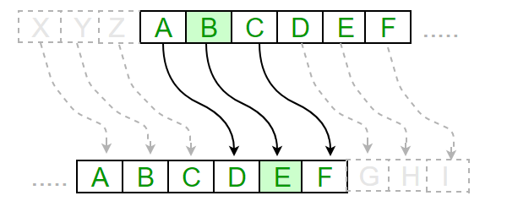
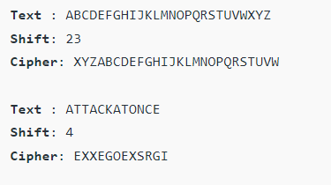
Julius Caesar secured messages by putting two sets of the alphabet side by side, and then shifting one of them by a specific number of places. In this case, the number of places in the shift serves as the key.
He converted plaintext into ciphertext using this key, and only his generals, who also had the key, knew how to decipher the messages.
The Caesar cipher, considered one of the oldest and simplest encryption methods.

Slide 9 - Caesar's cipher pros and cons
Advantages:
Easy to implement and use
It can be physically implemented
It only requires a small set of pre-shared information.
It can easily be modified to create a more secure variant
Disadvantages:
It is not secure against modern decryption methods.
Vulnerable to known plaintext attacks,
Vulnerable to a brute force attack.
Not suitable for long text encryption,
Not suitable for secure communications
It does not provide confidentiality, integrity and authenticity

Slide 10 - Polyalphabetic ciphers
A polyalphabetic cipher is any cipher based on substitution, using multiple substitution alphabets. This of course leads to a much larger number of possible keys.
The relationship between a character in the plain text and the characters in the cipher text is one-to-many.
The first Polyalphabetic cipher was the Alberti Cipher which was introduced by Leon Battista Alberti in the year 1467. It uses a random alphabet to encrypt the plaintext, but at different points and it can change to a different mixed alphabet, denoting the change with an uppercase letter in the ciphertext.
The Vigenère cipher is probably the best-known example of a polyalphabetic cipher, though it is a simplified special case.

Slide 11 - Vigenère Cipher
One example, maybe the most representative, of a polyalphabetic substitution cipher is the Vigenere cipher. In this case, the encryption of the original text is done using the Vigenère square or Vigenère table.
The table consists of the alphabets written out 26 times in different rows, each alphabet shifted cyclically to the left compared to the previous alphabet, corresponding to the 26 possible Caesar Ciphers.
At different points in the encryption process, the cipher uses a different alphabet from one of the rows.
The alphabet used at each point depends on a repeating keyword. In addition to the plaintext, the Vigenère cipher also requires a keyword, which is repeated so that the total length is equal to that of the plaintext.

Slide 12 - Vigenère Cipher - figure
In encrypting plaintext, the cipher letter is found at the intersection of the column headed by the plaintext letter and the row indexed by the key letter.
To decrypt ciphertext, the plaintext letter is found at the head of the column determined by the intersection of the diagonal containing the cipher letter and the row containing the key letter.
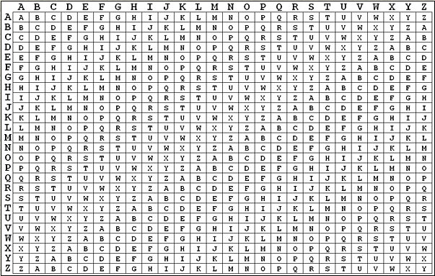
Slide 13 - Homophonic ciphers
The Homophonic Substitution Cipher involves replacing each letter with a variety of substitutes, the number of potential substitutes being proportional to the frequency of the letter.
They are generally much more difficult to break than standard substitution ciphers.
The number of characters each letter is replaced by is part of the key, e.g. the letter 'E' might be replaced by any of 5 different symbols, while the letter 'Q' may only be substituted by 1 symbol.

Slide 14 - Polygram ciphers
Polygram cipher systems are ciphers in which groups of letters are encrypted together, and include enciphering large blocks of letters.
An example of such ciphers includes Playfair.
The Playfair cipher was the first practical digraph substitution cipher.
The scheme was invented in 1854 by Charles Wheatstone, but was named after Lord Playfair who promoted the use of the cipher.
In Playfair cipher, unlike traditional cipher, we encrypt a pair of alphabets (digraphs) instead of a single alphabet.
It was used for tactical purposes by British forces in the Second Boer War and in World War I and for the same purpose by the Australians during World War II. This was because Playfair is reasonably fast to use and requires no special equipment.

Slide 15 - Transposition ciphers
So, until now, we have spoken about substitution ciphers. Let’s move on to the second type of classical ciphers, namely transposition ciphers.
Transposition ciphers are a bit different to Substitution ciphers. Whereas Substitution ciphers replace each letter with a different letter or symbol to produce the ciphertext, in a Transposition cipher, the letters are just moved around. That is why Transposition ciphers are also known as permutation ciphers.
The letters or words of the plaintext are reordered in some way, fixed by a given rule (the key).
Are more efficient than substitution ciphers.
The encrypted text preserves all the characters of the original text, but in a different order

Slide 16 - Enigma machine
Enigma machine is a famous encryption machine used by the Germans during WWII to transmit coded messages.
The Enigma machine was invented by a German engineer Arthur Scherbius shortly after WW1.
A variety of different models - the German military model, the Wehrmacht Enigma, is the most commonly discussed version.
Like other rotor machines, the Enigma machine is a combination of mechanical and electrical systems.
The mechanical mechanism consists of a keyboard; a set of rotating disks called rotors arranged adjacently along a spindle; and a stepping mechanism to turn one or more of the rotors with each key press.
The exact mechanism varies, but the most common form is for the right-hand rotor to step once with every keystroke, and occasionally the motion of neighbouring rotors is triggered.
The continual movement of the rotors results in a different cryptographic transformation after each key press.

Modern cryptography
In this video we will approach modern cryptography. We will start with cryptographic hash functions and then we will move on to symmetric and asymmetric encryption.

Slide 18 - Cryptographic hash functions
A cryptographic hash function has a somewhat different role compared to other cryptographic algorithms. It is used to return a value based on a piece of data, such as a file or a message, for example. Any accidental or intentional change to the data changes this hash value.
A cryptographic hash function is a mathematical function that takes an arbitrary amount of data input and produces a fixed-size output of enciphered text.
Values returned by a hash function are called message digest or simply hash values. That enciphered text can then be stored instead of the password itself, and later used to verify the user.
The length of this hash depends on the function used, but is generally between 128 and 512 bits.
These functions have an important role in authenticating the content of messages and obtaining electronic signatures.

Slide 19 - Properties of Hash Functions
In order to be an effective cryptographic tool, the hash function is desired to possess following properties:
Hash function converts data of arbitrary length to a fixed length - This process is often referred to as hashing the data.
Non-reversibility, or one-way function - A good hash should make it very hard to reconstruct the original password from the output or hash.
Collision resistance - It should be hard to find two different passwords that hash to the same enciphered text.
Non-predictable - The hash value should not be predictable from the password.

Slide 20 - Applications
Integrity checking is one of the important practical applications of hash functions, which can be achieved by comparing the hash of the message (or file) computed before and after transmission (or after any other event). For this reason, most digital signature algorithms only confirm the authenticity of the hash of the message to be "signed", the verification of the authenticity of this hash being also the proof of the authenticity of the message.
Another application is password security. Storing all user passwords in clear text can lead to a major security breach if the password file is compromised. Another way is to store only the hash of each password. To authenticate a user, the hash of the password presented by the user is compared to the stored hash (this approach, however, prevents the recovery of original passwords if they are forgotten or lost and need to be replaced with new ones).
Hash functions can also be used to generate pseudo random bits or to get new keys or passwords from a single secure key or password.
Cryptographic hash functions are widely used in cryptocurrencies to pass transaction information anonymously. For example, Bitcoin, the original and largest cryptocurrency, uses the SHA-256 cryptographic hash function in its algorithm. Similarly, IOTA, a platform for the Internet of Things, has its own cryptographic hash function, called Curl.

Slide 21 - Popular Hash functions
Some of the most popular hash functions are the following:
MD - Message Digest Algorithm (MD4, MD5)
SHA-1 – The Secure Hash Algorithm-1
SHA-2 family
SHA-3
RIPEMD-160

Slide 22 - Message Digest (MD)
The MD family comprises hash functions such as MD2, MD4, MD5 and MD6.
It was adopted as Internet Standard RFC 1321.
It is a 128-bit hash function.
One of the most important is MD4 which has influenced later designs (meaning all modern hash-code functions)
MD5 was designed by Ronald Rivest in 1991 to replace the earlier hash function MD4
MD5 was the most popular and widely used hash function for quite some years.
MD5 digests have been widely used in the software world to provide assurance about integrity of transferred files.
In 2004, collisions were found in MD5. An analytical attack was reported to be successful only in an hour by using a computer cluster. This collision attack resulted in compromised MD5 and hence it is no longer recommended for use.

Slide 23 - Secure Hash Function (SHA) family
Family of SHA comprises four SHA algorithms; SHA-0, SHA-1, SHA-2, and SHA-3. Though from the same family, they are structurally different.
The original version is SHA-0, a 160-bit hash function, was published by the National Institute of Standards and Technology (NIST) in 1993. It had few weaknesses and did not become very popular. Later in 1995, SHA-1 was designed to correct alleged weaknesses of SHA-0.
SHA-1 is a 160-bit hash function which resembles the earlier MD5 algorithm. It is employed in several widely used applications and protocols including Secure Socket Layer (SSL) security. Cryptographic weaknesses were discovered in SHA-1, and the standard was no longer approved for most cryptographic uses after 2010.
SHA-2 family has four further SHA variants, SHA-224, SHA-256, SHA-384, and SHA-512 depending on the number of bits in their hash value. Though SHA-2 is a strong hash function.The most commonly used SHA function today is SHA-256. SHA-2 applications: in widely used security protocols such as TLS (Transport Layer Security) and SSL (Secure Sockets Layer), PGP (Pretty Good Privacy), SSH (Secure Shell Protocol), S/MIME (Secure/Multipurpose Internet Mail Extensions), IPsec (Internet Protocol Security)
In October 2012, the NIST chose the Keccak algorithm as the new SHA-3 standard. Keccak offers many benefits, such as efficient performance and good resistance for attacks. SHA-3 is the latest member of the Secure Hash Algorithm family of standards, released by NIST on August 5, 2015.

Slide 24 - RIPEMD
The RIPEMD is an acronym for RACE Integrity Primitives Evaluation Message Digest.
This set of hash functions was designed by the open research community and generally known as a family of European hash functions.
The development idea of RIPEMD (the original RIPEMD) is based on MD4 which in itself is a weak hash function.
It is developed to work well with 32-bit processors.Types of RIPEMD: RIPEMD-128, RIPEMD-160, RIPEMD-256, RIPEMD-320
RIPEMD-160 is the most widely used version in the family.
RIPEMD-160 is heavily used in Bitcoin (along with SHA-256), resistant to cryptanalytic attacks, resistant to brute-force attacks, thanks to the 160-bit digest

Slide 26 - Cryptosystems
Fundamentally, there are two types of cryptosystems based on the manner in which encryption-decryption is carried out in the system: symmetric and asymmetric. The main difference between these cryptosystems is the relationship between the encryption and the decryption key. Logically, in any cryptosystem, both the keys are closely associated. It is practically impossible to decrypt the ciphertext with the key that is unrelated to the encryption key.
symmetric (with secret key) - use the same key for both encryption and decryption of messages
asymmetric (with public keys) - use two keys, one public and one private

Slide 27 - Cryptosystems - figure
In symmetric encryption, sender Alice encrypts her message with an agreed-upon shared key and sends the encrypted message to Bob. Bob receives the encrypted message and uses the shared key to decrypt the message.

In asymmetric encryption, sender Alice encrypts her message with a public key and sends the encrypted message to Bob. Bob receives the encrypted message and uses his private key to decrypt it.

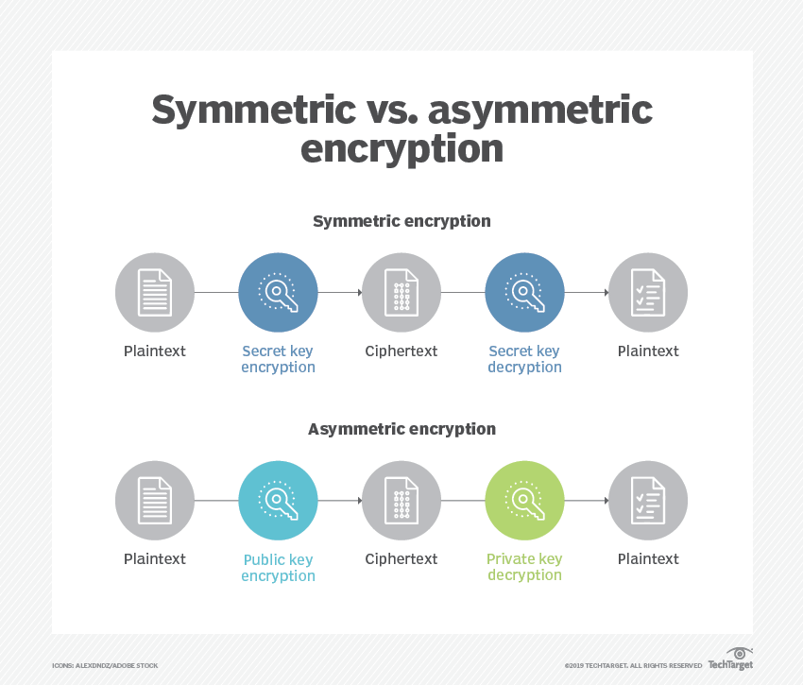
Slide 28 - Key Management
Key management includes the generation, exchange, storage, use and replacement of keys used in an encryption algorithm.
It is the most difficult part of designing a cryptosystem. Many cryptosystems have failed because of mistakes in their key management procedures.
In practice, most attacks on cryptographic systems target the key management level, rather than the cryptographic algorithm itself.
There are several essential characteristics of key management to consider.
Symmetric algorithms:
Best known as shared-secret key algorithms.
The usual key length is 80 to 256 bits.
A sender and a receiver must share a secret key.
Algorithms are usually quite fast (wire speed) because they are based on simple mathematical operations.
Asymmetric algorithms
Best known as public key algorithms.
The usual key length is 512 to 4096 bits.
A sender and a receiver do not share a secret key.
Algorithms are relatively slow because they are based on difficult computational operations.

Slide 29 - Keys
Two terms used to describe keys are:
Key length — Also called the key size, this is the length of the key in bits.
Keyspace — This is the number of possibilities that a specific key length can generate.
As key length increases, the keyspace increases exponentially. The keyspace of an algorithm is the set of all possible key values. Longer keys are more secure; however, they are also more resource intensive. Almost every algorithm has some weak keys in its keyspace that can enable a criminal to break the encryption via a shortcut.

Slide 30 - Difference Between Symmetric and Asymmetric Encryption
Symmetric encryption uses a single key that needs to be shared among the people who need to receive the message while asymmetric encryption uses a pair of public key and a private key to encrypt and decrypt messages when communicating.
Symmetric encryption is an old technique while asymmetric encryption is relatively new.
Asymmetric encryption was introduced to complement the inherent problem of the need to share the key in a symmetric encryption model, eliminating the need to share the key by using a pair of public-private keys.
Asymmetric encryption takes relatively more time than symmetric encryption.
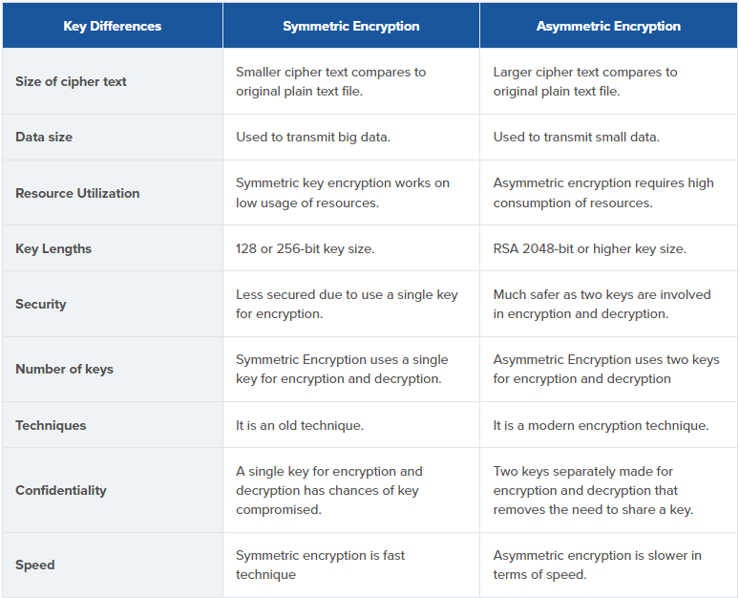
Conclusion
When it comes to encryption, the latest schemes may necessarily be the best fit.
You should always use the encryption algorithm that is right for the task at hand.
In fact, as cryptography takes a new shift, new algorithms are being developed in a bid to catch up with the eavesdroppers and secure information to enhance confidentiality. Hackers are bound to make it tough for experts in the coming years, thus expect more from the cryptographic community!

HOMEWORK

- Some ciphers were once thought unbreakable but later broken. Given that history, why might the Americans and French conclude that the Enigma cipher was unbreakable prior to the start of the Second World War?

- What do you think is weak encryption worse than no encryption at all?

- Why does Bitcoin need a hash?

